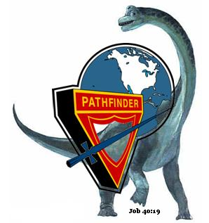



Induction Certificate

This certifies that

*Adrian Arzaluz*

*has been inducted into membership of the*

*Lake of the Woods Pathfinder Club*

*on February 5, 2011.*

Mitchell Alvarez

Pathfinder Director

__________________________________

__________________________________

Erika Alvarez

Pathfinder Associate Director